**Software Architecture and Design**

Course Work

ONLINE STORE SELLING FLOWERS

Variant - 11

*Prepared by:*

*students of SE-224B,*

*Anna Kuts’and*

*Alexander Trukhin*

*Accepted by:*

*Vasilieva M.D.*

Зміст

INTRODUCTION 2

PART 1 2

Software requirements specification 2

Design patterns 2

Builder pattern 2

Singleton pattern 2

Decorator pattern 2

PART 2 2

Build system in the project 2

Representation of functional requirements 2

Unit tests for business logic 2

CONCLUSION 2

# INTRODUCTION

In this course work, we developed a site for selling flowers. In addition to the functional requirements in the task, we added: creation of custom bouquets, and menu admin to manage orders and flower products. The Maven build system was chosen to create a Java project. And for representation, they chose an interface - a web application.

# PART 1

## Software requirements specification

|  |  |
| --- | --- |
| F 1 | Viewing the assortment of flowers |
| F 1.1 | Ability to view a variety of colors available for purchase |
| F 1.2 | Categorization of flowers by type, color, seasonality, etc |
| F 1.3 | Displaying detailed information about each type of flower (name, description, price, size, etc.) |
| F 1.4 | Photos of flowers for a better visual presentation |
| F 2 | Create custom bunch |
| F 2.1 | Control of the number of added flowers and total cost of bunch |
| F 2.2 | Custom bunch builder window for better customization, usability |
| F 2.3 | Photo of custom bunch for a better visual presentation |
| F 2.4 | Adding bunch to the basket |
| F 3 | Search and filtering |
| F 3.1 | Ability to search flowers by name, color, price etc |
| F 3.2 | Color filtering by various parameters |
| F 4 | Adding flowers to the basket |
| F 4.1 | The possibility of adding flowers to the basket for further processing of the order |
| F 4.2 | Control of the number of added flowers and their total cost |
| F 5 | Placing an order |
| F 5.1 | Filling out the form with the buyer's contact information and delivery address |
| F 5.2 | Choice of delivery method (courier delivery, pickup, postal delivery,etc.) |
| F 5.3 | Choice of payment method (online payment, cash on delivery, etc.) |
| F 6 | Order confirmation |
| F 6.1 | Sending confirmation of receipt of the order by e-mail |
| F 7 | Notification system |
| F 7.1 | Sending notifications to users about the status of their order (accepted, paid, in processing, shipped, delivered) |
| F 8 | Admin menu |
| F 8.1 | Interact with orders |
| F 8.1.1 | Show list of orders |
| F 8.1.2 | Show specific order |
| F 8.1.3 | Update status of specific order |
| F 8.1.4 | Sent email notification of update status in specific order |
| F 8.1.5 | Delete specific order |
| F 8.2 | Interact with products |
| F 8.2.1 | Show list of products |
| F 8.2.2 | Show specific product |
| F 8.2.3 | Update information and photo about product |
| F 8.2.4 | Delete specific product |
| F 8.2.5 | Add new product |
| NF 1 | The user interface should be intuitive and easy to use |
| NF 2 | The system should have documentation for developers |
| NF 3 | The email notification system should process user requests in no more than 1 minute. |

## Design patterns

### Builder pattern

We used Builder patterns for step-by-step creation of objects - flower, bouquet and order.

Bunch Builder:

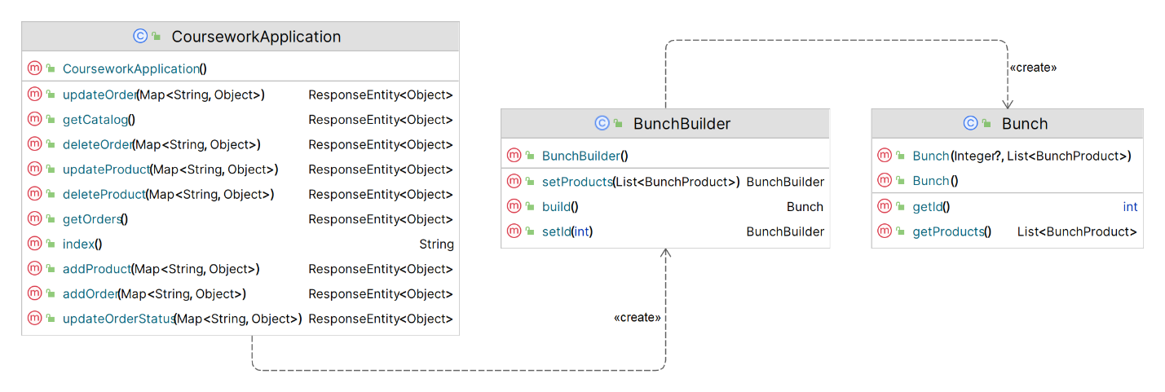

Product Builder:

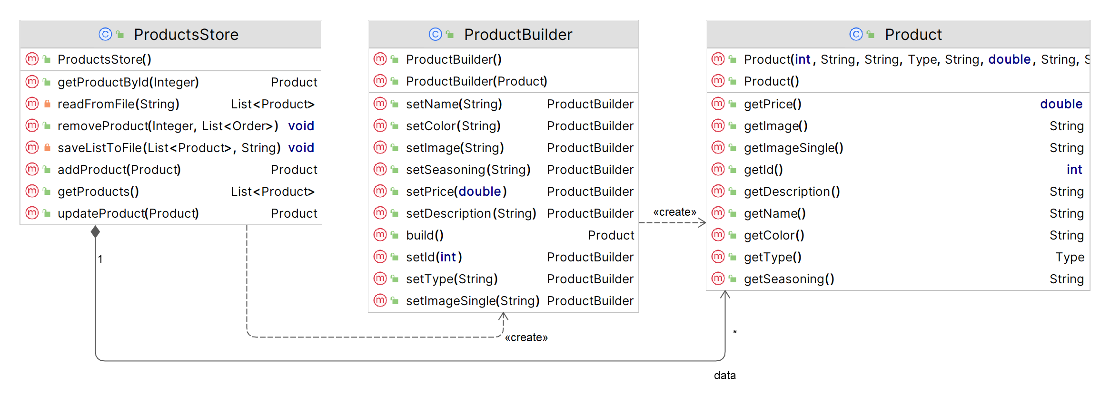 Order Builder:

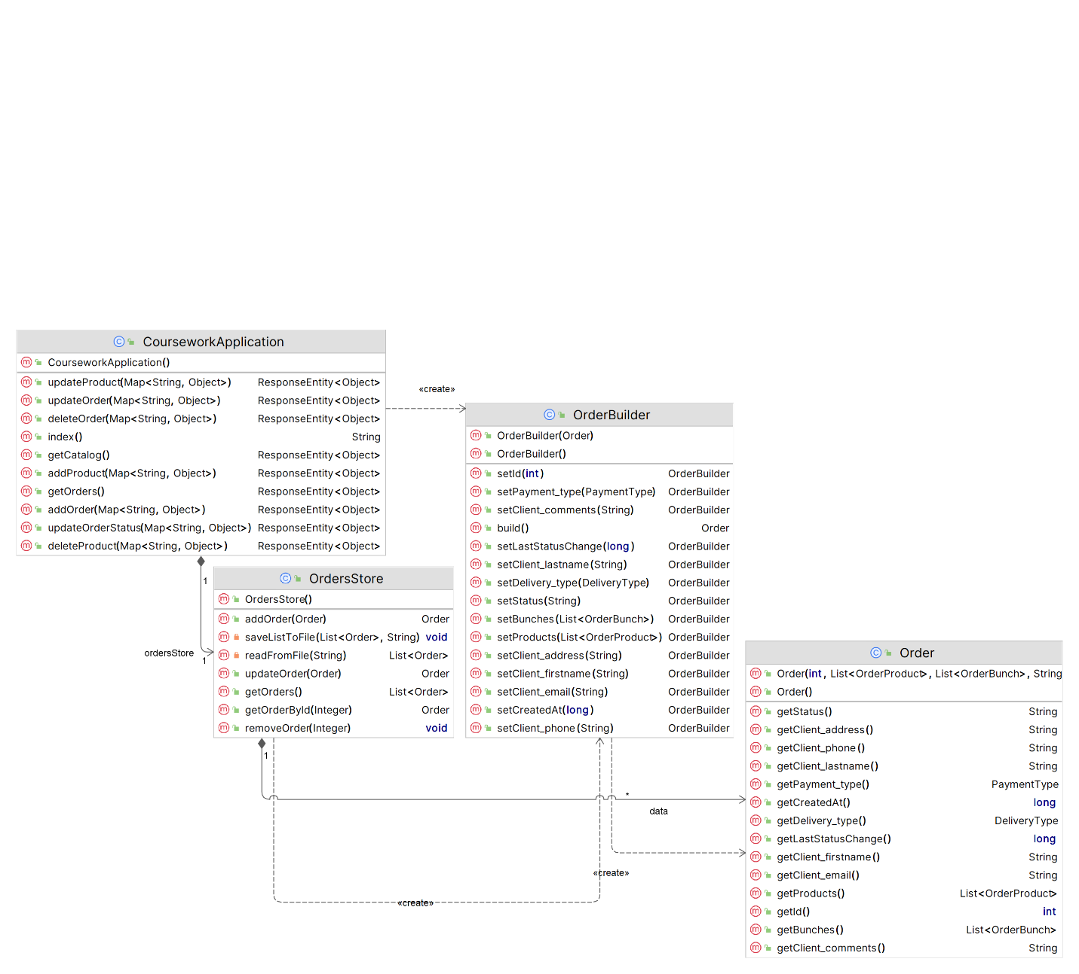

### Singleton pattern

We used the Singleton pattern so that there was only one instance of the class interacting with the database.

Orders Store Singleton:

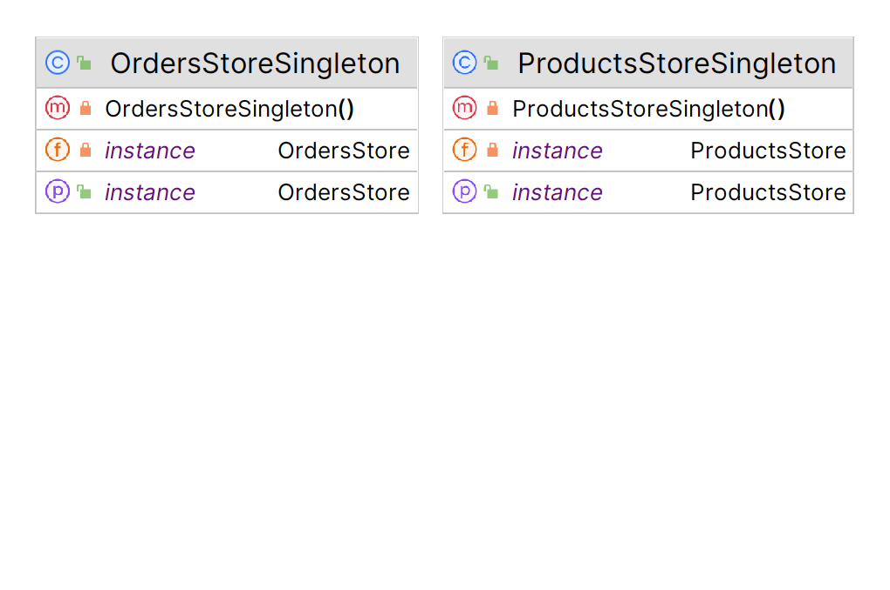

Products Store Singleton:



### Decorator pattern

We used the Decorator pattern, for the perspective of developing the catalog of bouquets and, to the application - adding a wrapper, now we have only 1 "decorator" - the number of identical bouquets, which are already a complex object (an array of various flowers).

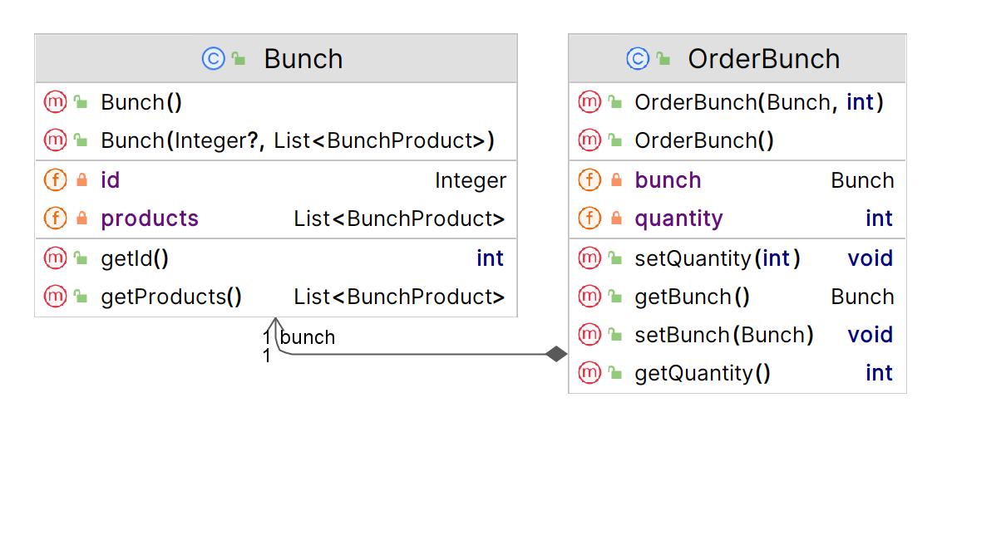

# PART 2

## Build system in the project

We used the Maven build system to build the Java project.

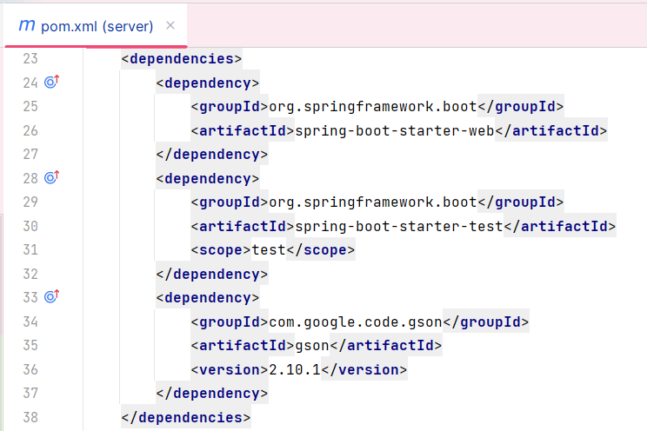

## Representation of functional requirements

F 1 Viewing the assortment of flowers

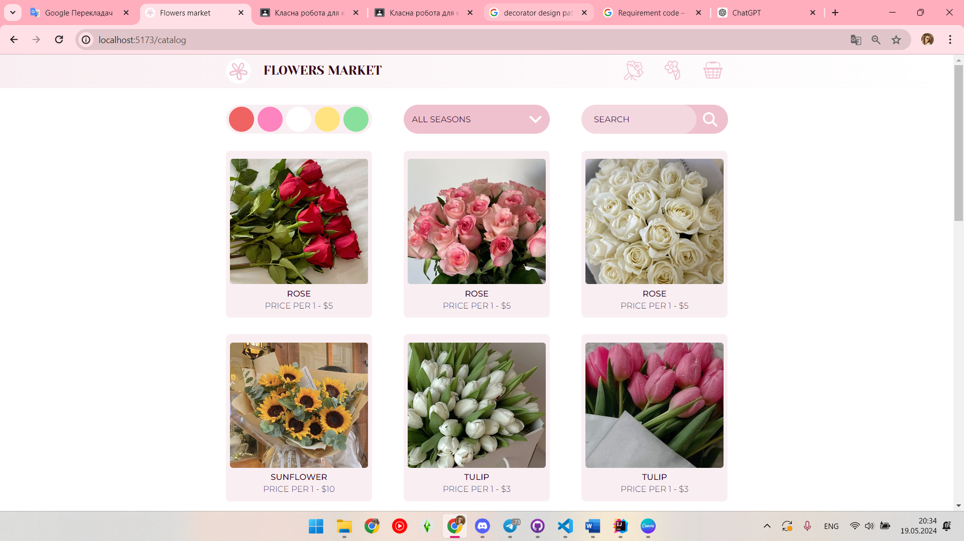

F 1.1 Ability to view a variety of colors available for purchase

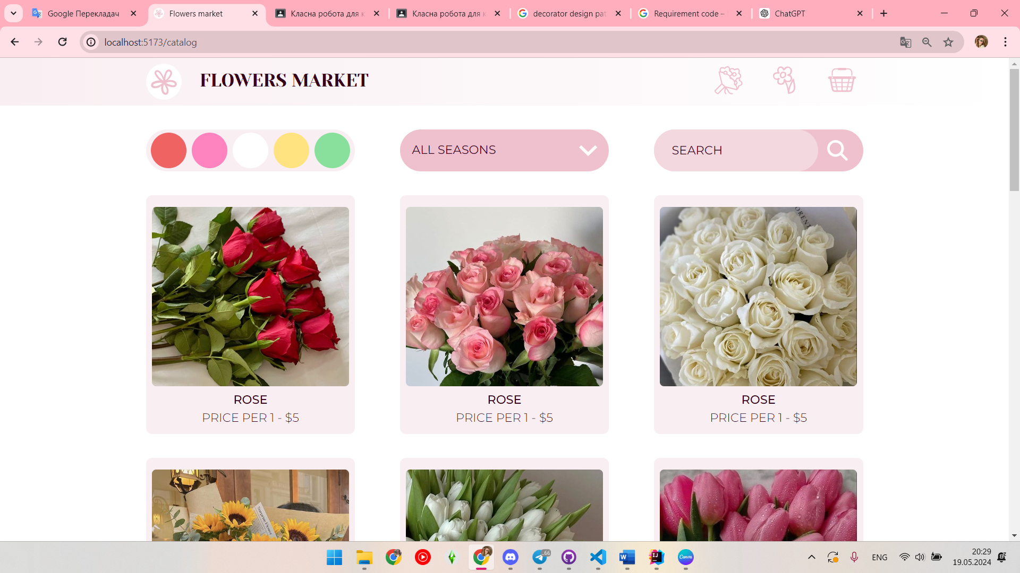

F 1.2 Categorization of flowers by type, color, seasonality, etc

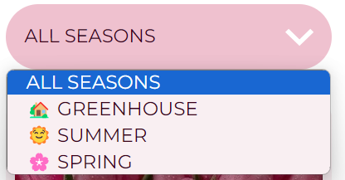

F 1.3 Displaying detailed information about each type of flower (name, description, price, size, etc.)

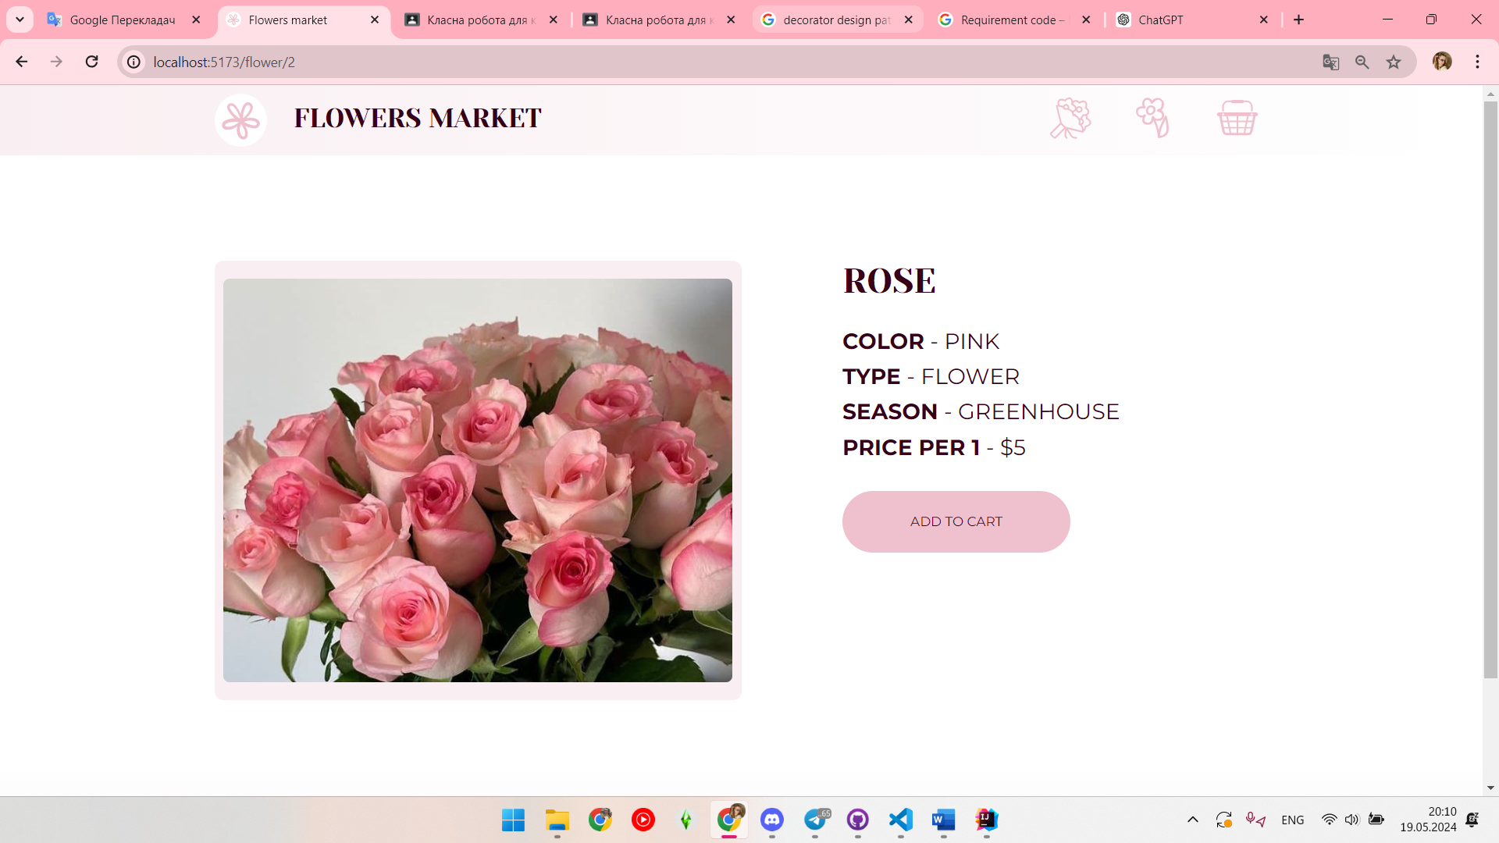

F 1.4 Photos of flowers for a better visual presentation

F 2 Create custom bunch

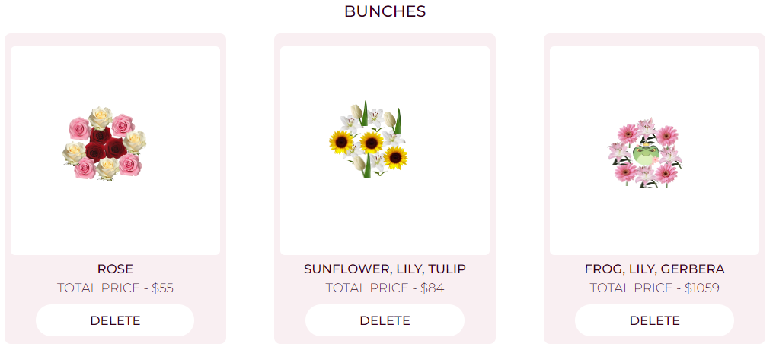

F 2.1 Control of the number of added flowers and total cost of bunch

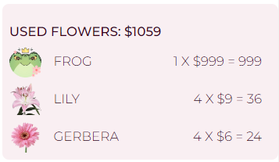

F 2.2 Custom bunch builder window for better customization, usability

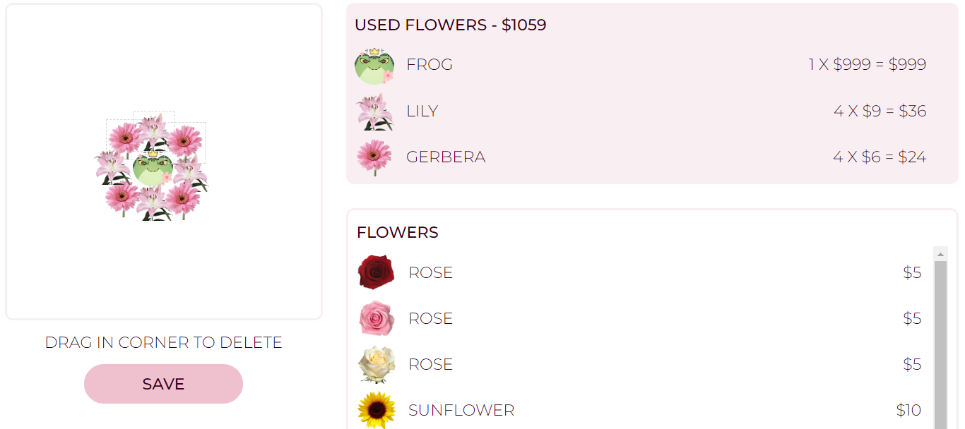

F 2.3 Photo of custom bunch for a better visual presentation

F 2.4 Adding bunch to the basket

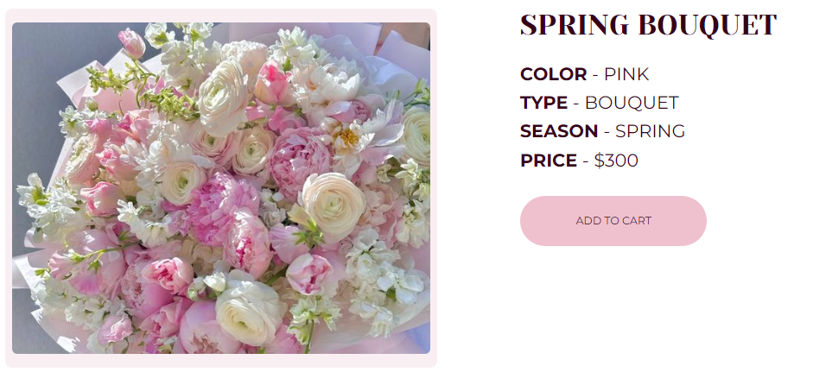

F 3 Search and filtering

F 3.1 Ability to search flowers by name, color, price etc



F 3.2 Color filtering by various parameters

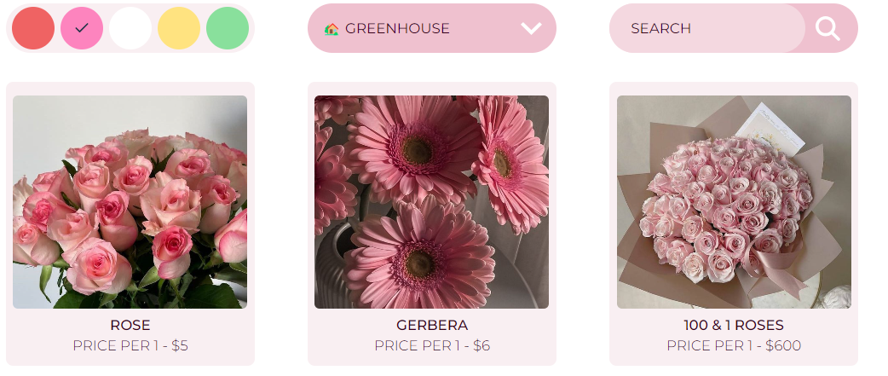

F 4 Adding flowers to the basket

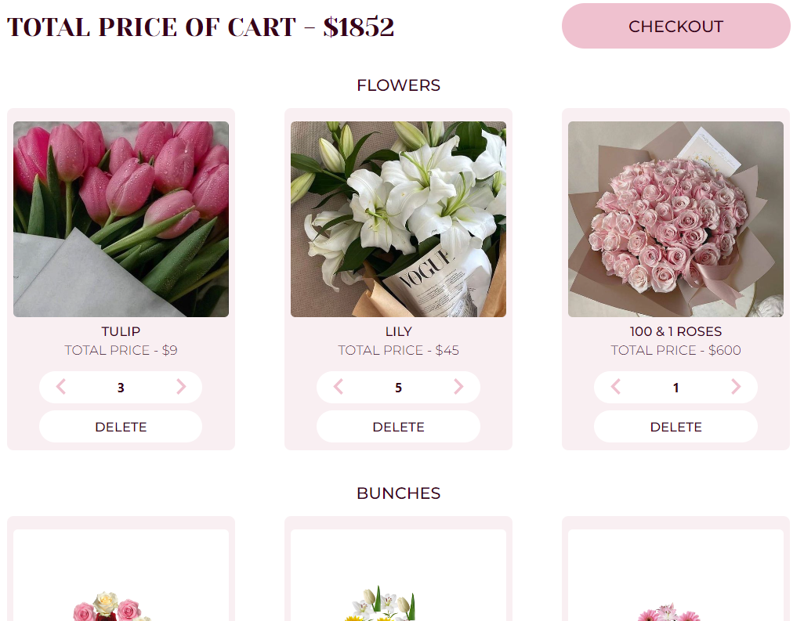

F 4.1 The possibility of adding flowers to the basket for further processing of the order

F 4.2 Control of the number of added flowers and their total cost

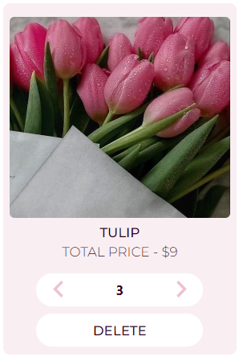

F 5 Placing an order

F 5.1 Filling out the form with the buyer's contact information and delivery address

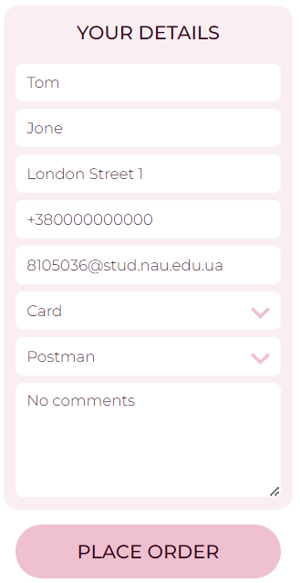

F 5.2 Choice of delivery method (courier delivery, pickup, postal delivery,etc.)

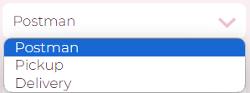

F 5.3 Choice of payment method (online payment, cash on delivery, etc.)

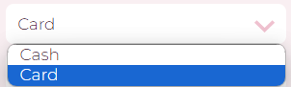

F 6 Order confirmation

F 6.1 Sending confirmation of receipt of the order by e-mail

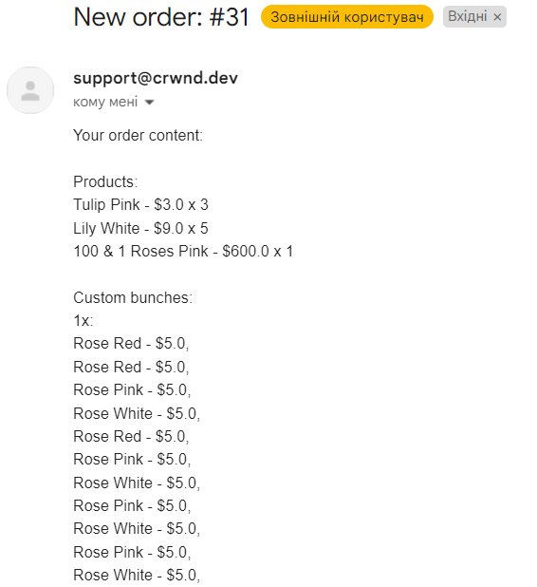

F 7 Notification system

F 7.1 Sending notifications to users about the status of their order (accepted, paid, in processing, shipped, delivered)



F 8 Admin menu

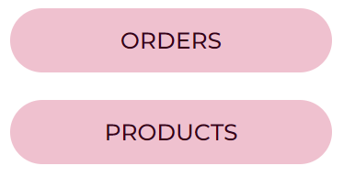

F 8.1 Interact with orders

F 8.1.1 Show list of orders

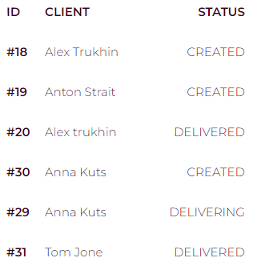

F 8.1.2 Show specific order

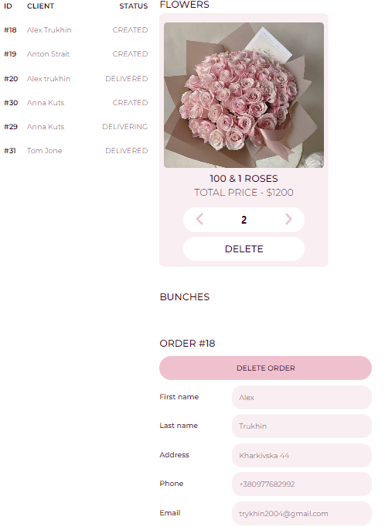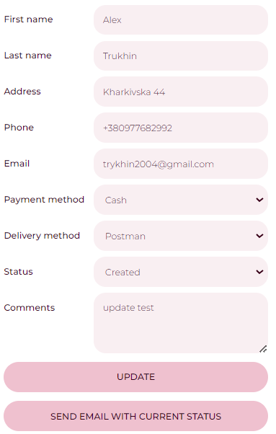

F 8.1.3 Update status of specific order

F 8.1.4 Sent email notification of update status in specific order

F 8.1.5 Delete specific order

F 8.2 Interact with products

F 8.2.1 Show list of products

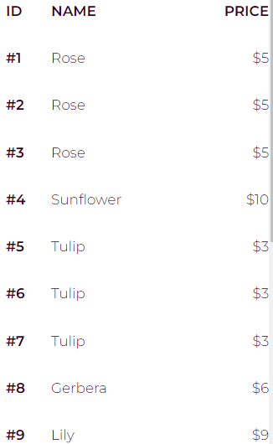

F 8.2.2 Show specific product

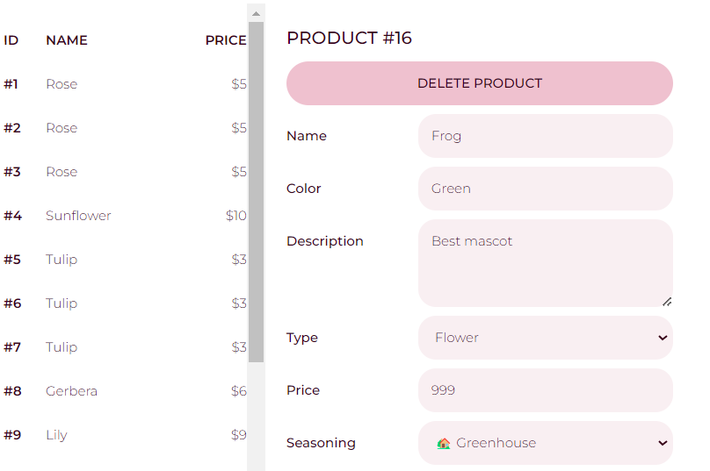

F 8.2.3 Update information and photo about product



F 8.2.4 Delete specific product

F 8.2.5 Add new product

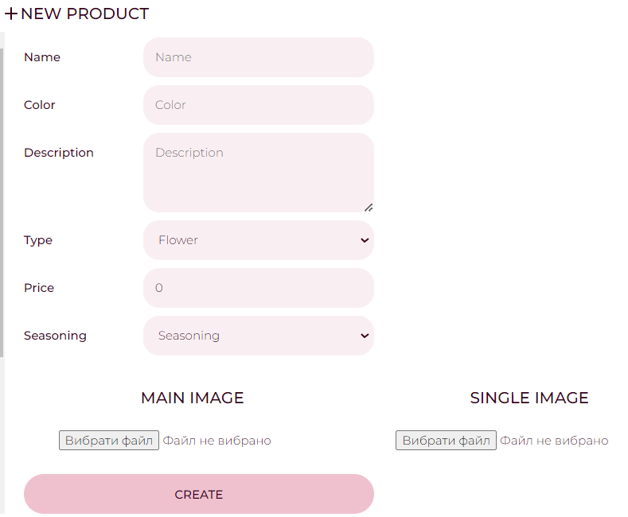

## Representation of functional requirements

F 1 Viewing the assortment of flowers



F 1.1 Ability to view a variety of colors available for purchase



F 1.2 Categorization of flowers by type, color, seasonality, etc



F 1.3 Displaying detailed information about each type of flower (name, description, price, size, etc.)



F 1.4 Photos of flowers for a better visual presentation

F 2 Create custom bunch



F 2.1 Control of the number of added flowers and total cost of bunch



F 2.2 Custom bunch builder window for better customization, usability



F 2.3 Photo of custom bunch for a better visual presentation

F 2.4 Adding bunch to the basket



F 3 Search and filtering

F 3.1 Ability to search flowers by name, color, price etc



F 3.2 Color filtering by various parameters



F 4 Adding flowers to the basket



F 4.1 The possibility of adding flowers to the basket for further processing of the order

F 4.2 Control of the number of added flowers and their total cost



F 5 Placing an order

F 5.1 Filling out the form with the buyer's contact information and delivery address



F 5.2 Choice of delivery method (courier delivery, pickup, postal delivery,etc.)



F 5.3 Choice of payment method (online payment, cash on delivery, etc.)



F 6 Order confirmation

F 6.1 Sending confirmation of receipt of the order by e-mail



F 7 Notification system

F 7.1 Sending notifications to users about the status of their order (accepted, paid, in processing, shipped, delivered)



F 8 Admin menu



F 8.1 Interact with orders

F 8.1.1 Show list of orders



F 8.1.2 Show specific order



F 8.1.3 Update status of specific order

F 8.1.4 Sent email notification of update status in specific order

F 8.1.5 Delete specific order

F 8.2 Interact with products

F 8.2.1 Show list of products



F 8.2.2 Show specific product



F 8.2.3 Update information and photo about product



F 8.2.4 Delete specific product

F 8.2.5 Add new product



## Representation of non-functional requirements

## Unit tests for business logic

We used JUnit tests for testing business logic of program in Java.

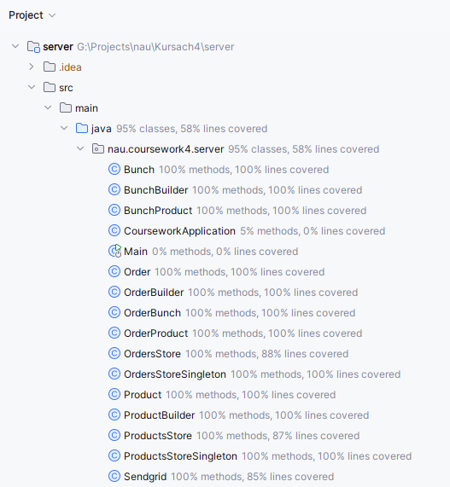

# CONCLUSION